DAFFODIL INTERNATIONAL UNIVERSITY

DEPARTMENT OF CIS
LAB REPORT-01

COURSE CODE : CIS 216
COURSE TITLE : OBJECT ORIENTED PROGRAMMING

SUBMITTED BY SUBMITTED TO
MARFI HAQUE ANTARA NASIMUL KADER
ID: 253-16-029 SENIOR LECTURER
SECTION: 23A DEPARTMENT OF CIS, DIU
Year: 2nd Semester:4th
DATE OF SUBMISSION : 28 SEPTEMBER,2026
1.
Code:
public class HelloWorld {
public static void main(String[] args) {
System.out.println("Hello World!");
}
}

Output:
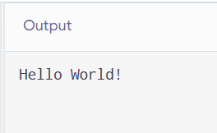

2.
Code:
public class Daffodil{
public static void main(String[] args) {
{
System.out.println("This is inside the block.");
}

System.out.println("This is outside the block.");
}
}

Output:
